LCHS
Art
Super Curricular Activities



WATCH

https://artsandculture.google.com/story/mAUhHW4vOVDErA?hl=en

https://www.royalacademy.org.uk/article/10-artist-movies-and-documentaries-to-watch-on-netflix-amazon-iplayer

https://www.bbc.co.uk/iplayer/episode/b0074q0f/roy-lichtenstein-pop-idol

https://www.edx.org/course/european-paintings-from-leonardo-to-rembrandt-to-g

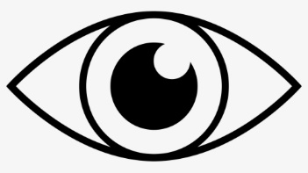

There is a wide selection of art books in the school library.

https://www.wallpaper.com/art/best-art-books-guide
https://fivebooks.com/category/art-books/
William Morris – The Lesser Arts of Life https://www.marxists.org/archive/morris/works/1882/life1.htm
Why have there been no great women artists? https://canon.hypotheses.org/files/2012/01/whynogreatwomenartists_4.pdf

E.H. Gombrich, The Story of Art John Berger Ways of Seeing Griselda Pollock,
Vision and Difference Svetlana Alpers, The Art of Describing John Ruskin Edward Said,
Orientalism, 1978. T.J. Clark, Image of the People Alberti,
On Painting 1450, On Sculpture,
On the Art of Building 1443-52 Vasari,
Lives of the Most Excellent Painters, Sculptors, Architects

READ




https://www.my-mooc.com/en/mooc/art/
https://www.bbc.co.uk/programmes/p01drwny
Tate Gallery Podcasts, exploring the human stories behind art:
https://www.tate.org.uk/art/podcasts
National Gallery Podcasts on a range of art topics by artists, authors and historians: https://www.nationalgallery.org.uk/podcast/podcasts

LISTEN

FOLLOW
Why not follow your favourite artist or art critic?
Alternatively, why not follow the Tate Modern, MOMA or another of your favourite galleries? You could follow galleries from around the world!

ART UK is an online site bringing together artworks, artists and topics you can discover, view and read about: https://artuk.org/
The Student Art Guide is a site featuring articles, guidance, student art work and resources: https://www.studentartguide.com/


RESEARCH

https://www.open.edu/openlearn/history-the-arts/art-and-visual-culture-medieval-modern/content-section-1.1.6
https://www.futurelearn.com/courses/fashion-innovation
https://www.futurelearn.com/courses/introducing-art-history-discovering-public-sculpture
https://www.dezeen.com/
https://www.futurelearn.com/courses/royal-fashion
https://www.futurelearn.com/courses/art-crime
https://www.open.edu/openlearn/history-the-arts/art-and-visual-culture-medieval-modern/content-section-1.1.6

Prof. Jimmy Choo invites YOU to the
Sustainability Sketching Challenge! https://app4.campus-site.com/public/e/view/4m0Q0agtSqdXKXP1Bg8ycA

https://www.moma.co.uk/uk-art-competitions/

https://www.archdaily.com/801871/10-essential-freehand-drawing-exercises-for-architects

Create a small sketchbook of 'samples' of experiments with different media and techniques. Each page should be like a piece of abstract art which explores texture, tone, special effects. Some of these might explore mixed media or other techniques.

CREATE



VISIT
Why not visit a local exhibition?

https://www.travelandleisure.com/attractions/museums-galleries/museums-with-virtual-tours

https://www.royalacademy.org.uk/

https://www.fitzmuseum.cam.ac.uk/research/online-resources

https://www.oxfordartonline.com/groveart

https://artsandculture.google.com/partner?hl=en

https://www.coursera.org/learn/modern-art-ideas

Domestica – offer other online art courses



APPS

https://www.makeuseof.com/free-apps-and-sites-to-learn-how-to-draw-online/

https://www.format.com/magazine/resources/illustration/drawing-apps

• Pinterest
• Adobe Photoshop
• Adobe Photoshop Sketch

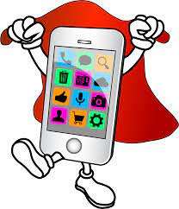

LCHS
ART
Super Curricular Activities

